
WESTERN PACIFIC UNIVERSITY
CMN224 / CMP224 Software Engineering
Waghi Valley Produce Cooperative · ULO1 and ULO2 · 15% · due Week 11 ·
Student: Ben Bay
ID: 00137
Lecture: Mr S. Hombiku

Task 4 — Design & Modelling Deliverable

Task 4 — Design & Modelling Deliverable
]

0. Scope, assumptions and what changed from the labs
This deliverable assembles Lab 4 (Week 5 architecture) and Lab 6 (Week 9 behavioural diagrams) into one consistent model of an offline-first produce, farmer and sales system for the Waghi Valley Produce Cooperative.

Requirements used for traceability
ID | Requirement (from Lab 4)
FR-01 | Register and maintain farmer / producer records
FR-02 | Record each produce delivery (type, quantity, date) against a farmer
FR-03 | Record sales of produce to buyers
FR-04 | Issue a receipt for every sale
FR-05 | Farmers can see only their own records
FR-06 | Staff can request reversal of a sale; only a manager can approve it
FR-07 | Synchronise records between devices and the local server without duplicates
FR-08 | Produce sales and payout reports for management
NFR-01 | Role-based login; permissions enforced by the system, not the screen
NFR-02 | Offline-first: keep working during power or Wi-Fi outage with no data loss

1. Use-case model (Scenarios view)
Three internal roles use the system: Farmer, Cooperative Staff and Cooperative Manager. The Buyer is outside the system and only receives a receipt copy. Every actor is a role, every use case is a goal, and the system boundary is drawn.
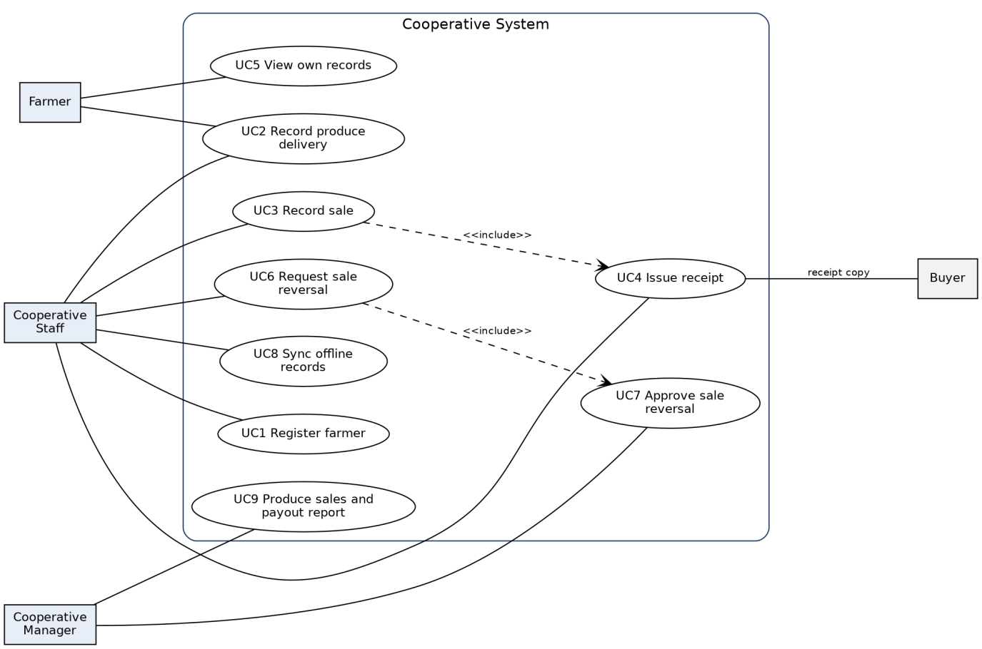
Figure 1 — Use-case diagram: 4 actors, 9 use cases
Decision recorded: Approve sale reversal is a separate use case for the Manager only, included by Request sale reversal, so that no staff member can approve their own correction (FR-06).
Use case | Actor | Requirement
UC1 Register farmer | Cooperative Staff | FR-01
UC2 Record produce delivery | Cooperative Staff, Farmer | FR-02, NFR-02
UC3 Record sale | Cooperative Staff | FR-03
UC4 Issue receipt (included by UC3) | Cooperative Staff | FR-04
UC5 View own records | Farmer | FR-05, NFR-01
UC6 Request sale reversal | Cooperative Staff | FR-06
UC7 Approve sale reversal (included by UC6) | Cooperative Manager | FR-06, NFR-01
UC8 Sync offline records | Cooperative Staff (Farmer app runs it automatically) | FR-07, NFR-02
UC9 Produce sales and payout report | Cooperative Manager | FR-08

2. Class diagram (Logical view)
Seven classes with named associations and multiplicity at both ends. Every attribute traces to a requirement.
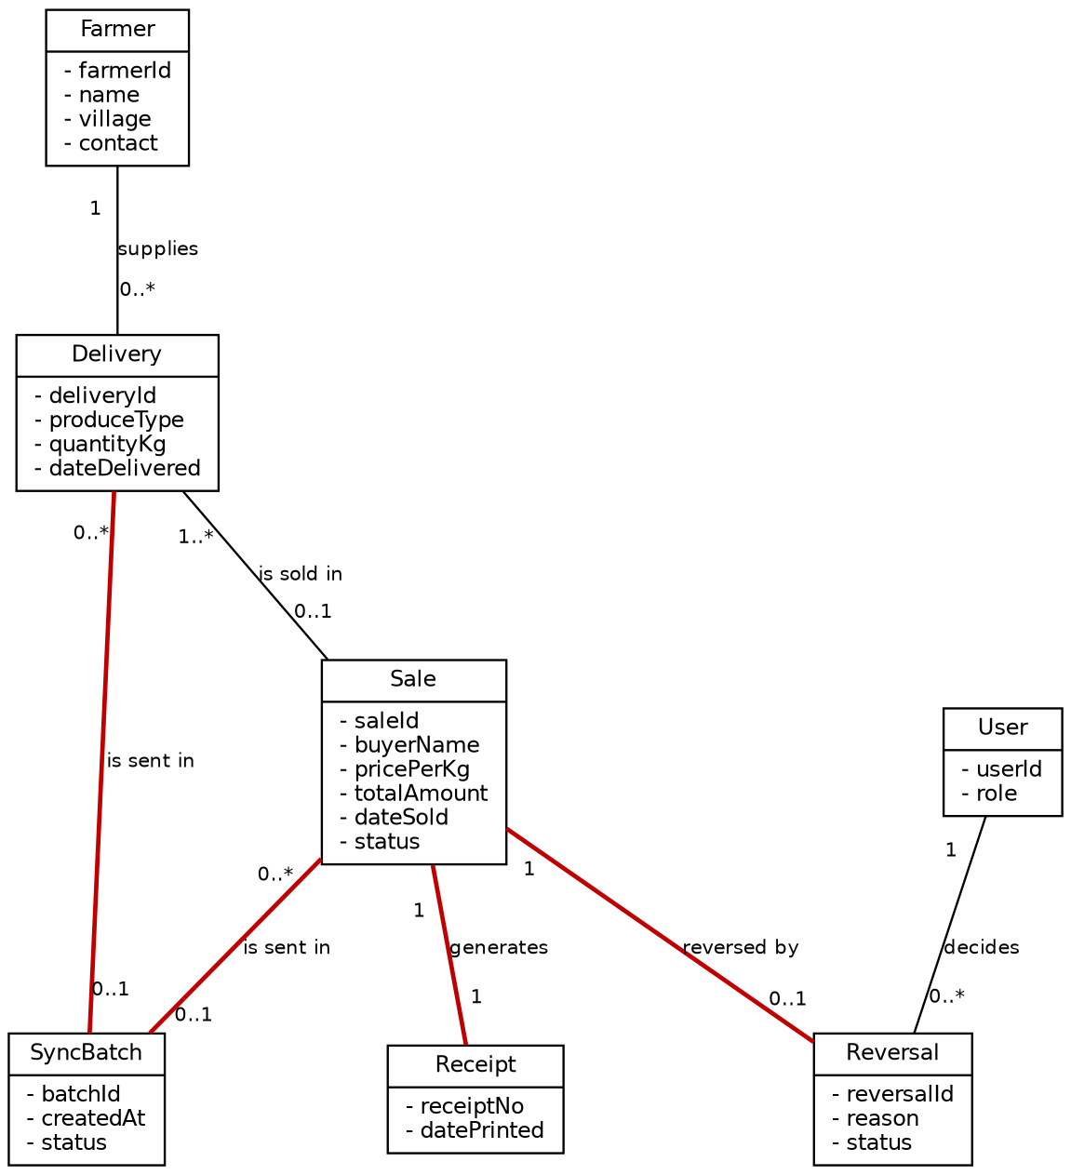
Figure 2 — Class diagram (red links carry business rules)
Decision recorded: the multiplicities carry business rules: every sale generates exactly one receipt (Sale 1 — 1 Receipt, FR-04); a sale can be reversed at most once (Sale 1 — 0..1 Reversal, FR-06); a delivery or a sale belongs to at most one sync batch, which keeps import duplicate-safe (Delivery 0..* — 0..1 SyncBatch and Sale 0..* — 0..1 SyncBatch, FR-07). A delivery can also be sold in at most one sale, so produce cannot be sold twice (FR-03).
Class | Attributes | Requirement
Farmer | farmerId, name, village, contact | FR-01
Delivery | deliveryId, produceType, quantityKg, dateDelivered | FR-02
Sale | saleId, buyerName, pricePerKg, totalAmount, dateSold, status | FR-03
Receipt | receiptNo, datePrinted | FR-04
Reversal | reversalId, reason, status | FR-06
SyncBatch | batchId, createdAt, status | FR-07
User | userId, role | NFR-01

3. State diagram (Sale lifecycle)
A sale is Recorded, then Receipted. With no link it becomes Queued (held offline), then Synced when the link returns. A synced sale can go to Reversal pending and end as Reversed, or the period closes and it ends as Closed.
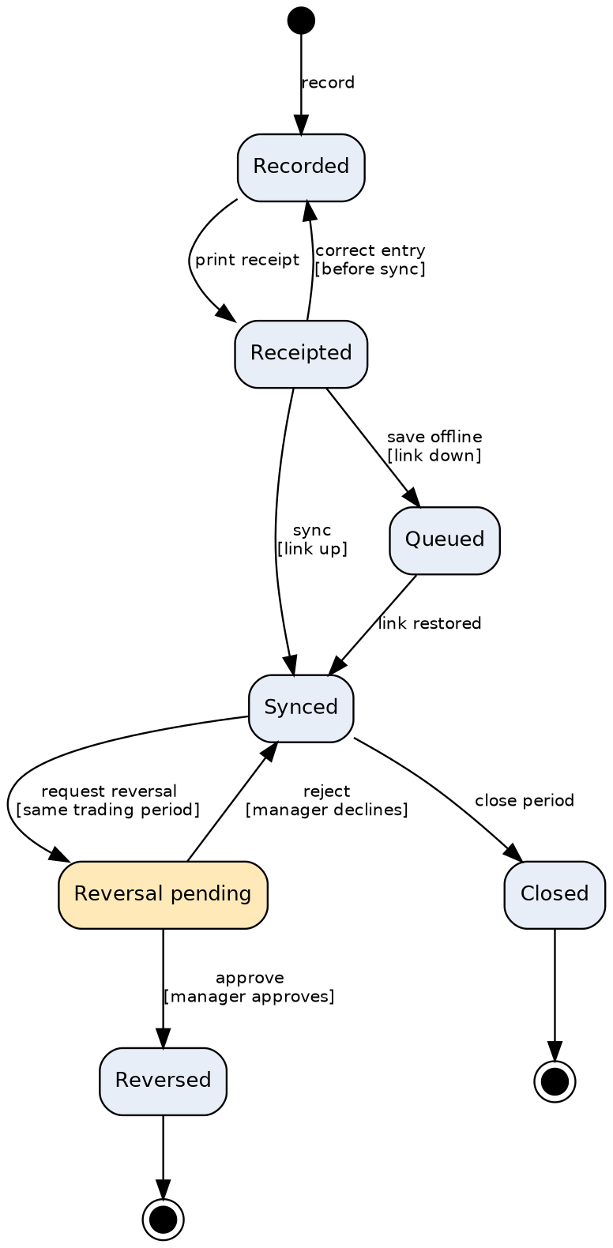
Figure 3 — State diagram: sale lifecycle
Decision recorded: two transitions carry guards from business rules: approve [manager approves] and request reversal [same trading period]. A third guard, correct entry [before sync], stops edits to records the server already holds.

4. Activity diagram with swimlanes
Workflow: record a delivery and sale, print the receipt, and sync to the Local Server. Lanes are Farmer Smartphone, Staff PC and Local Server, exactly the processing devices in the deployment view.
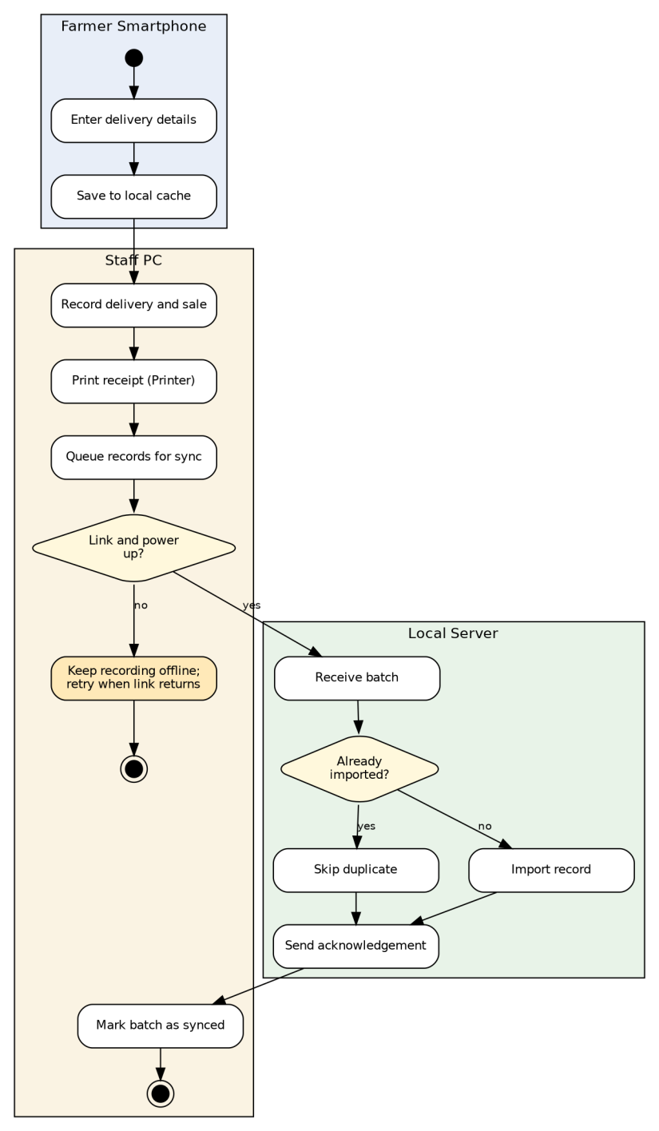
Figure 4 — Activity diagram with swimlanes (offline branch highlighted)
Decision recorded: the decision node “Link and power up?” gives the offline branch: staff keep recording and printing, changes wait in the queue, and the retry happens when the link returns. The Local Server checks “Already imported?” so a repeated batch never creates duplicates.

5. Outline architecture (Development view: package diagram)
Four layers with downward-only dependencies: Presentation, Application Logic, Data Access, Storage. Role-based Access Control sits inside Application Logic, so every request from either interface passes a permission check before data is reached.
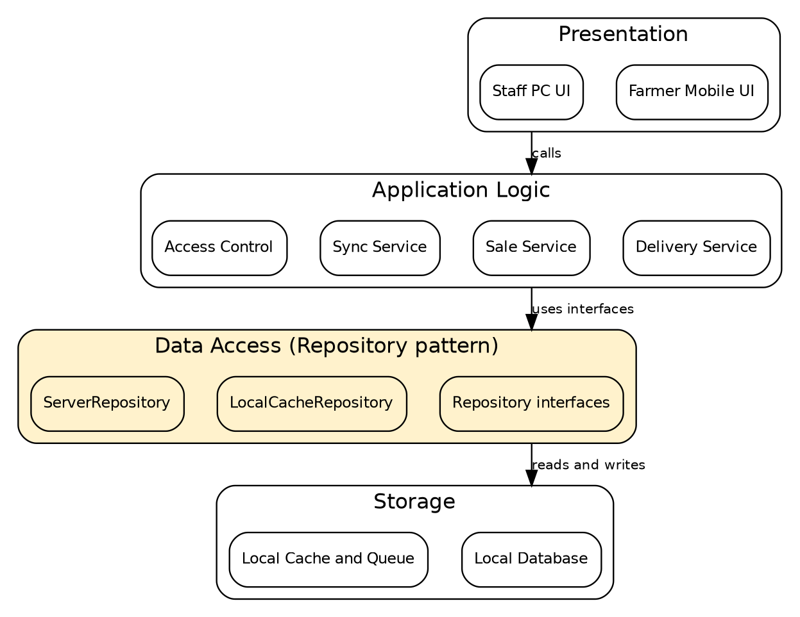
Figure 5 — Package diagram: four layers, no upward arrows
Decision recorded: layered architecture was chosen over client–server with one central database, because that design needs continuous connectivity and fails the offline requirement NFR-02 at a site with unreliable internet.

6. Deployment view (Physical view)
Four nodes: Farmer Smartphone, Staff PC, Local Server and Printer. The smartphone and the Staff PC each keep local data so they work with the link down.
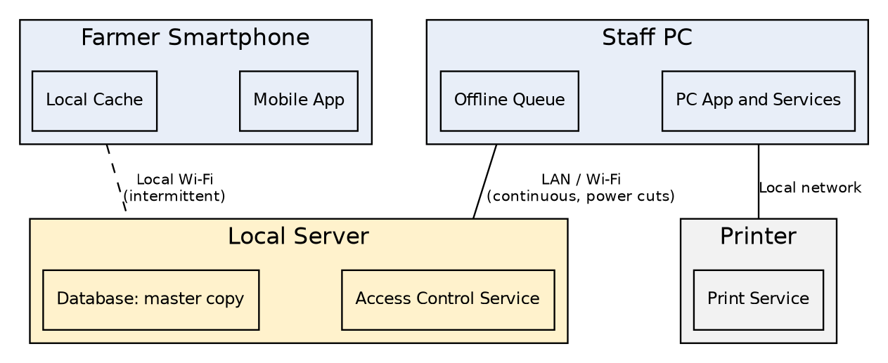
Figure 6 — Deployment diagram (dashed link = intermittent)
Decision recorded: the Local Server on the Cooperative premises is the single master copy of the data, because the Waghi Valley internet link is unreliable. Nothing depends on the internet.
Node | Software | Data held | Link | Still works when link is DOWN
Farmer Smartphone | Mobile App | Local Cache: own Farmer record, Delivery, SyncBatch (unsent) | Local Wi-Fi to Local Server, intermittent | Enter deliveries; view own cached records
Staff PC | PC App and Services, Access Control client | Offline Queue: Delivery, Sale, Receipt, Reversal, SyncBatch | LAN / Wi-Fi to Local Server, continuous but exposed to power cuts | Record sales, print receipts, queue for sync
Local Server | Database, Access Control Service | All classes, master copy | Local network | Devices queue their work
Printer | Print Service | none | Local network to Staff PC | Receipts print from the Staff PC

Class-to-machine placement
Class | Smartphone | Staff PC | Local Server
Farmer | own record (cache) | yes | master
Delivery | yes | yes | master
Sale | no | yes | master
Receipt | no | yes (printed via Printer) | master
Reversal | no | yes | master
SyncBatch | yes | yes | master
User | login token only | login token only | master (Access Control Service)

7. Design pattern applied: Repository (inside the layered structure)
- Named: Repository pattern, within the layered architecture from Week 5.
- Located: in the Data Access package. The Application Logic services (SaleService, DeliveryService, SyncService) call interfaces such as SaleRepository and DeliveryRepository. There are two implementations: LocalCacheRepository (smartphone and Staff PC offline queue) and ServerRepository (Local Server database).
- What it buys: the business logic does not know whether data comes from the cache or the server, so the same code works online and offline; storage can change without touching the services; and services can be tested with a fake repository.

8. Consistency checks
# | Check | Result
1 | Every use case traces to a requirement | Done in section 1 — confirm the IDs match your SRS
2 | Every class attribute appears in the requirements | Done in section 2 — confirm wording against your SRS
3 | A multiplicity encodes a business rule | Pass: Sale 1—1 Receipt; Sale 1—0..1 Reversal; Delivery and Sale 0..*—0..1 SyncBatch
4 | A transition carries a guard from a business rule | Pass: approve [manager approves]; request reversal [same trading period]
5 | Offline / no-power branch in the activity diagram | Pass
6 | Swimlanes match deployment devices | Pass: Farmer Smartphone, Staff PC, Local Server
7 | Every class is placed on a machine | Pass: class-to-machine table in section 6
8 | No upward dependency arrow | Pass: Presentation → Application Logic → Data Access → Storage
9 | One scenario traces through all five views | Pass: section 9
10 | Pattern named, located, justified | Pass: section 7

9. One scenario through all five views
Scenario: during a power cut, a farmer delivers 50 kg of produce. Staff record the delivery and a sale to a buyer, print a receipt, and sync when power returns.
View | How the scenario appears
Scenarios (use cases) | UC2 Record produce delivery, UC3 Record sale, UC4 Issue receipt, UC8 Sync offline records
Logical (class and state) | Delivery and Sale are created; Receipt is generated 1:1; the Sale moves Recorded → Receipted → Queued → Synced; a SyncBatch carries the records
Process (activity) | Save to cache, print receipt, queue records, decision “Link and power up?” = no, keep recording offline and retry, then the Local Server imports and acknowledges
Development (package) | Mobile UI or PC UI → Sale Service with Access Control → Repository (cache) → later Repository (server) → Database
Physical (deployment) | Records sit in the Staff PC Offline Queue and smartphone Local Cache until the link returns, then reach the Local Server

10. AI-use declaration
PlantUML and diagram drafts were produced with Claude (Anthropic) from my Lab 4 and Lab 6 work. I checked each diagram against my own SRS, in particular the offline branch, the reversal approval chain and the requirement IDs. [Edit this statement to be true before you submit.

